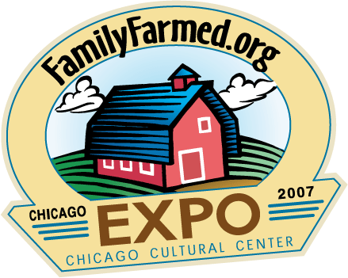

FamilyFarmed.org EXPO
MARCH 23 & 24, 2007
@ The Chicago Cultural Center

Contact: Jim Slama
312.951.8999 ext. 107

Press Registration

Register as press at least one week before the EXPO and get free admission and a press pass.

First Name

Last Name

Title/Position

Publication Name (or Freelance)

Audience: Local City Statewide National International

Primary Media Type: Print Radio TV Online Other

Email

Phone Number

Fax Number

Website

Mailing Address

City

State and Zip

